Development Platform Introduction

**Jiashu Wu**

2nd May 2018

Table of Contents

1. IDE 3

2. Gradle Build Version 4

3. SDK Information 4

4. Version Control Platform 4

5. Testing Device and Android Version 5

6. Testing Virtual Device and Android Version 5

7. Virtual Device Configuration 6

8. External Jar Files 7

8.1 Java Mail for Android 7

# 1. IDE

Android Studio 3.0.1

Build #AI-171.4443003, built on November 10, 2017

JRE: 1.8.0_152-release-915-b01 amd64

JVM: OpenJDK 64-Bit Server VM by JetBrains s.r.o

Windows 10 10.0

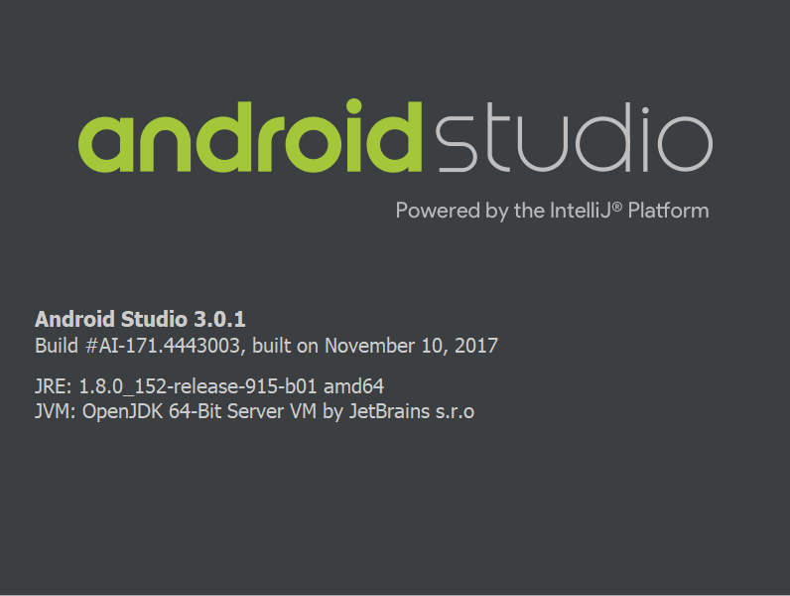

Download Link: <https://developer.android.com/studio/archive?authuser=1>

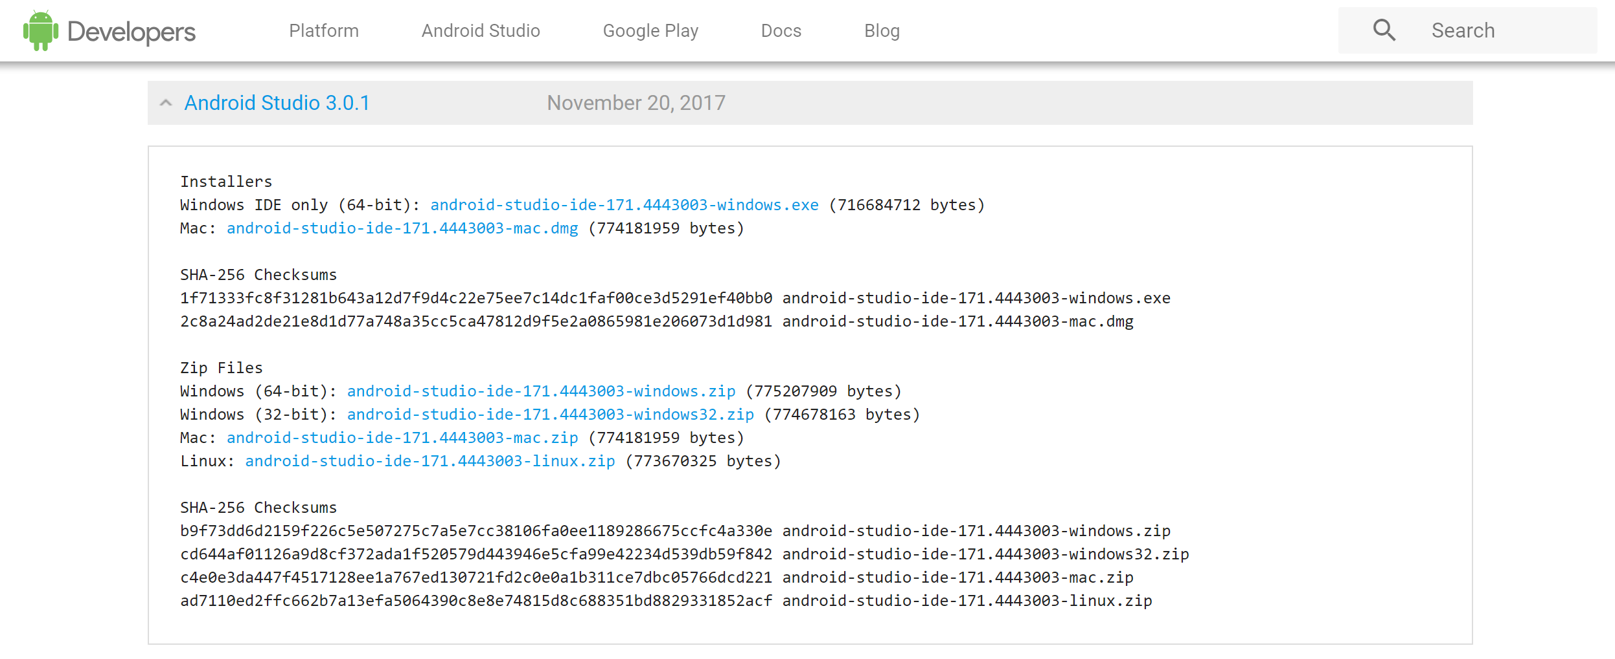

# 2. Gradle Build Version

Gradle Build Version: 3.0.1

# 3. SDK Information

Application Targeted SDK: 26

Application Minimum SDK: 15

# 4. Version Control Platform

Version Control Platform: Github

# 5. Testing Device and Android Version

Samsung Tab A with S Pen, with Android 7.1.1

Huawei FIG-AL10, with Android 8.0.0

# 6. Testing Virtual Device and Android Version

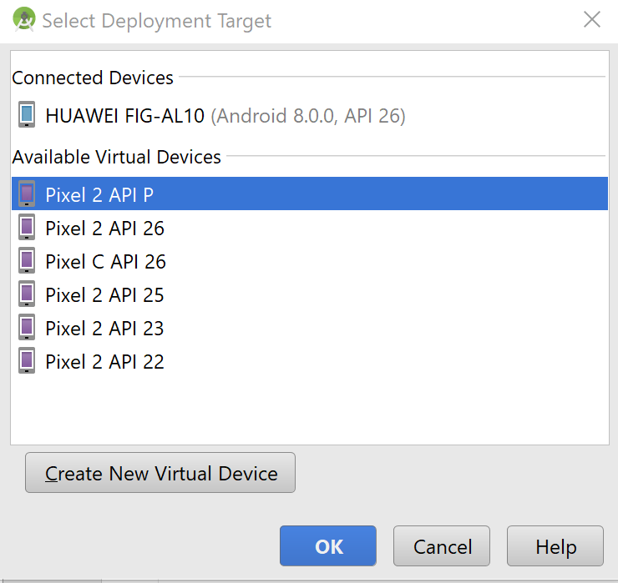Google Pixel 2 with Android P

Google Pixel 2 with Android 8.0.0

Google Pixel C with Android 8.0.0

Google Pixel 2 with Android 7.1.1

Google Pixel 2 with Android 6.0

Google Pixel 2 with Android 5.0

# 7. Virtual Device Configuration

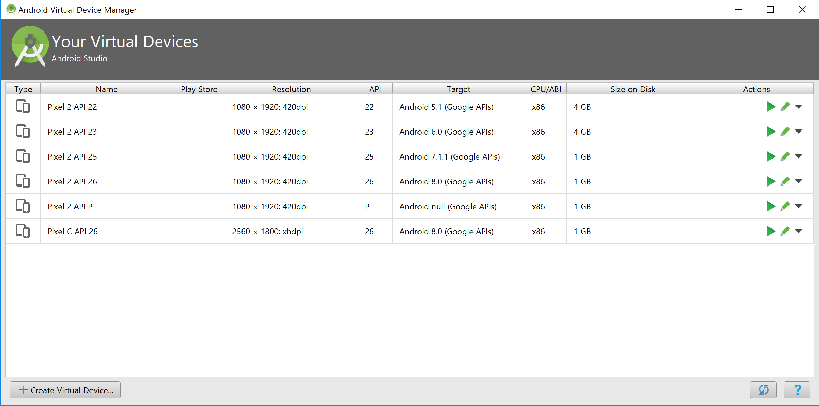

# 8. External Jar Files

## 8.1 Java Mail for Android

Download Links:

<https://code.google.com/archive/p/javamail-android/downloads>

